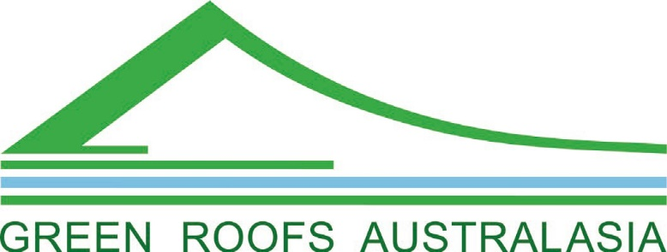

PRESIDENT REPORT:
Annual General Meeting 05/01/2022
The AGM detailed many challenges that will need to be overcome in 2022 and beyond.
There has been a shift towards online interaction due to border closures between states and a general lack of sustained mobility by all populations.
Public events have been cancelled and we will need to provide online seminars and discussion.
In 2021 our membership dramatically dropped as it did in 2020. Sponsorship has also declined due to the impacts on the commercial sector.
The combination of a decline in both membership and sponsorship resulted in our worst financial year.
Our presence on social media platforms like Instagram, linkedin and facebook has remained consistent and grown over 2021. However we do not generate membership or sponsorship through these networks, so we will need to engage professional advice on how to achieve a financial benefit.

GRA is still a member of the World Green Infrastructure Network and as a board member, I can report that we have made vital contacts within the EU Environmental Agency which have been successful for promoting our mission and key policy inclusions to mitigate:-
- loss of fauna & flora
- loss of homes and animal habitat
- dangerous health warnings for air quality & urban heat
- record temperatures, drought & precipitation
- natural environment erosion
- destruction of natural habitat areas
- GHG emissions

OUR ADVOCACY 2021

GRA continued to provide assistance to the capital city governments of Sydney, Melbourne & Brisbane by developing guidelines and policy strategies to support a greater inclusion of green spaces within urban areas, specifically for the built environment.
GRA also provided free membership for the Institute of Landscape Architects (AILA) to support professional development throughout Australasia. Free membership was also provided to the general public.

AGM KEY MOTIONS PASSED by QUORUM

• To expand our mission to include green infrastructure. This will diversify our sponsor target group to also include all landscaping services within the commercial sector.
• To expand our website service with podcasts; blogs and online seminars. This will improve our industry reach and improve membership.
• To engage a social media employee.
• To engage an association secretary rather than relying on a volunteer.
• To provide free membership to all industry sectors.

NEW COMMITEES
Sponsorship Committee: To review our sponsorship fees and benefits.
Marketing Committee: To determine new marketing strategies.
Research Committee: To increase our associations as a stakeholder and to collect new data.

CONCLUSION
Thank you to all our loyal volunteers, members and sponsors for supporting GRA through our most challenging year since formation in 2008.
Regards
Matthew Dillon
GRA President

